Spatiotemporal Feature-Enhanced and Task-Coupled Lightweight Byzantine Consensus Mechanism
Qi Yu ¹, Kai Di², Chengge Duan¹, Yichuan Jiang ²⁺
¹(School of Cyber Science and Engineering, Southeast University, Nanjing 211189, China)
²(School of Computer Science and Engineering, Southeast University, Nanjing 211189, China)
+ Corresponding author: Y. Jiang(E-mail: yjiang@seu.edu.cn)
Abstract: Traditional Byzantine Fault Tolerance (BFT) and its existing improved mechanisms often struggle to meet the performance requirements of industrial multi-agent systems due to high computational and communication complexity. These limitations hinder their applicability in real-time, resource-constrained environments, leading to issues such as high latency and communication overhead. To address these challenges, we propose a Spatiotemporal Feature-Enhanced and Task-Coupled Lightweight Byzantine Consensus Mechanism (STCL-BFT). Our mechanism incorporates three core improvements: first, spatiotemporal features are embedded into consensus messages to prevent replay attacks and ensure data integrity; second, the consensus process is limited to task-coupled agents, which significantly reduces unnecessary communication; third, an adaptive weight mechanism is introduced to dynamically adjust the influence of nodes based on their behavior, thereby enhancing the overall robustness against malicious activities. Experimental evaluations conducted using CORE Emulator show that our mechanism achieves up to 85% lower communication costs and over 60% faster consensus formation compared to PBFT. These results demonstrate the potential of STCL-BFT to enhance both the security and efficiency of consensus processes in real-time industrial systems.
Keywords: Lightweight Byzantine Consensus; Spatiotemporal Feature; Task-Coupled Consensus; Adaptive Weight Mechanism; Consensus Robustness

INTRODUCTION
The Byzantine consensus mechanism [8] was originally designed to address the problem of achieving consensus among multiple nodes in a distributed system in the presence of malicious or faulty nodes. It is a reliable coordination mechanism with fault tolerance, providing the ability to reach consensus in untrusted environments, thereby mitigating the disruptive influence of malicious nodes on system operations. Byzantine Fault Tolerance (BFT) plays a crucial role in distributed control, data replication, block chain, and multi-agent systems, enabling nodes to reach agreement even in the presence of unreliable components.
Currently, classical Byzantine consensus mechanisms, such as PBFT, perform well in resisting malicious behaviors through multiple rounds of message exchange and verification [9]. However, traditional Byzantine consensus methods are often computation-intensive and resource-consuming, limiting their applicability in real-time or resource-constrained environments, such as industrial multi-agent systems [10, 19]. Industrial systems are characterized by real-time requirements and the heterogeneity of agents, which necessitate consideration of communication overhead and computational complexity when implementing Byzantine mechanisms. The inefficiencies of traditional methods can lead to task coordination delays, reduced system robustness, and inadequate responsiveness to dynamic real-world scenarios [11, 20]. At the same time, the interactive temporal nature of tasks and the spatial context within industrial systems offer opportunities for improving Byzantine consensus mechanisms to better fit industrial requirements.
To address the limitations of traditional Byzantine methods, we propose a new consensus mechanism: the Spatiotemporal Feature-Enhanced and Task-Coupled Lightweight Byzantine Consensus Mechanism. This mechanism aims to overcome several challenges inherent in traditional BFT methods: high communication complexity, significant consensus latency, and excessive bandwidth usage. To meet these challenges, our approach incorporates the following innovative features:
First, nodes include timestamps and spatial location information in all messages. This addition ensures the uniqueness of each message, making it more resistant to replay attacks. The integration of spatial information also helps validate the physical context of messages, adding an extra layer of security.
Second, unlike traditional BFT mechanisms where all nodes participate in consensus, our mechanism introduces a task-coupled model. Only those nodes that have a direct relationship to the task are required to participate in the consensus process. This significantly reduces communication load and focuses consensus on critical task pairings.
Furthermore, we propose a dynamic weight mechanism that adjusts each node's influence in the consensus based on its historical behavior. Initially, all nodes are assigned equal weights, but repeated suspicious actions (e.g., sending conflicting information) result in weight reduction, minimizing the impact of potentially compromised nodes.
We conducted experiments on an industrial multi-agent system using CORE Emulator, which included multiple AGVs, robot arms, and a scheduling system. The mechanism was tested in scenarios involving malicious nodes attempting replay attacks and sending conflicting data. Experimental results indicate that, compared to PBFT, our improved mechanism reduced the overall communication cost by approximately 85% and increased the consensus formation speed by over 60%.
The contributions of this paper are as follows:
1. Enhanced Security with Spatiotemporal Features: By integrating timestamps and spatial information, we effectively defend against replay attacks and other malicious network behaviors, adding a critical security layer to the consensus process.
2. Task-Coupled Consensus Mechanism: We propose a lightweight consensus approach that involves only those nodes directly related to the task, thereby reducing communication overhead and computational complexity.
3. Adaptive Weight Mechanism: By dynamically adjusting the influence of nodes in the consensus based on historical behavior, our mechanism reduces the impact of malicious nodes and promotes overall system robustness.
We conducted experiments in an industrial multi-agent environment, demonstrating that our new method significantly reduces communication overhead and improves consensus efficiency.

RELATED WORK
Goyal et al. [2] proposed ReLI, a real-time lightweight Byzantine consensus for low-power IoT systems, by utilizing synchronous-transmission mechanisms to enhance efficiency. However, their work focuses on optimizing real-time consensus for resource-constrained IoT systems and does not explicitly consider leveraging spatiotemporal features to reduce replay attacks, nor the task-coupling model to further minimize communication overhead as our method does.
Kong et al. [1] introduced LAP-BFT, a lightweight asynchronous provable Byzantine fault-tolerant consensus mechanism tailored for UAV networks, which uses vector commitments and reduces data storage requirements on the chain. Although LAP-BFT reduces communication and computational overhead, it does not consider the use of explicit spatiotemporal data and a task-coupling approach for further optimizing consensus efficiency and robustness, which are key innovations in our proposed mechanism.
Jin et al. [3] proposed a Simplified Byzantine Fault Tolerant Consensus (SBFC) algorithm aimed at improving the efficiency of blockchain-based distributed energy trading markets. This algorithm optimizes communication complexity and protocol security by introducing a threshold signature mechanism and a Byzantine node detection scheme. However, SBFC did not cover the dynamic weight mechanism and task-coupling model, still faces issues of high communication complexity, significant consensus delay, and high bandwidth usage, especially in large-scale systems where efficiency decreases significantly with malicious node involvement.
Kapitza et al. [4] proposed CheapBFT, a resource-efficient Byzantine fault tolerance that focuses on reducing resource usage by cutting down unnecessary message passing. Although CheapBFT reduces communication complexity, it does not incorporate a task-coupling approach that directly focuses on consensus participants based on their current roles and tasks, which significantly lowers the consensus burden and makes our approach more suited for industrial multi-agent systems.
Wu et al. [5] presented a reinforcement learning-based Byzantine Fault-Tolerant (BFT) system that dynamically selects the top-performing BFT protocols in real-time to enhance adaptability and efficiency. However, their proposed method primarily focuses on addressing the traditional BFT methods’ rigidity and inflexibility by employing a decentralized learning approach and a multi-armed bandit framework. While it offers a significant improvement in protocol selection, it does not specifically address communication complexity, consensus delays, or bandwidth consumption issues, which are critical challenges in contemporary distributed systems. Thus, our proposed method, which incorporates spatiotemporal features and task coupling, addresses these overlooked aspects, bringing added value to the BFT field.
Zhao et al. [6] proposed a lightweight model-based evolutionary consensus protocol named Proof of Evolutionary Model (PoEM) for Blockchain as a Service (BaaS) in IoT environments. While PoEM effectively addresses efficiency and scalability issues by leveraging machine learning to enhance consensus processes in resource-constrained settings, it does not specifically tackle challenges related to communication complexity, consensus delays, and bandwidth consumption that are inherent in traditional Byzantine Fault Tolerance (BFT) methods, which distinguishes our method in terms of resilience and security optimization.
Li et al. [7] presented a dynamic adaptive framework (DA-PBFT) to optimize the Practical Byzantine Fault Tolerance (PBFT) consensus protocol for IoT environments, utilizing a multi-agent architecture and deep reinforcement learning. However, their approach primarily addresses the challenges of decision-making consistency and incomplete information in dynamic IoT contexts, without focusing specifically on communication complexity, consensus delays, and bandwidth consumption. This indicates a gap in their methodology, as it does not encompass the need for timestamp and spatial information integration for enhancing message uniqueness and context validation, nor does it consider the potential benefits of a task coupling model to reduce communication load by limiting consensus participation to directly relevant nodes.

Byzantine problem modeling of industrial multi-agent systems
In an industrial environment, a multi-agent system consists of multiple participants, including a scheduling system, AGVs (Automated Guided Vehicles), and Robot Arms [12]. These participants communicate with each other through TCP/IP protocols or specialized industrial protocols enhanced with real-time mechanisms. Each participant plays a different role in the system:
The Scheduling System acts as the coordination center, responsible for receiving and distributing tasks, and managing the execution of tasks throughout the system.
AGV (Automated Guided Vehicle): AGVs are responsible for transporting materials in industrial scenarios. Each AGV can navigate independently and perform material handling tasks according to the scheduling system's instructions. AGVs have six states:
- AGV_idle indicates that the AGV is idle and ready to accept tasks.
- AGVMovingToRobotArm indicates that the AGV is moving to the designated Robot Arm position.
- AGVAtRobotArm indicates that the AGV has arrived at the Robot Arm's location and is ready to hand over materials.
- AGVMovingToOrigin indicates that the AGV is returning to the initial position after completing material transportation.
- AGVAtOrigin indicates that the AGV has reached the starting point and is ready to execute the next task.
- AGV_abnormal indicates that the AGV is in an abnormal state, such as due to power failure or other issues.
Robot Arm: Robot Arms are responsible for processing materials. A Robot Arm receives materials delivered by an AGV and performs processing tasks, working in coordination with the AGV to complete specific operations. Robot Arms have three states:
- RobotArm_idle indicates that the Robot Arm is idle and waiting for materials to arrive.
- RobotArm_producing indicates that the Robot Arm is processing the assigned production task.
- RobotArm_abnormal indicates that the Robot Arm is in an abnormal state.
The schematic diagram of the entire system is shown in Fig. 1.
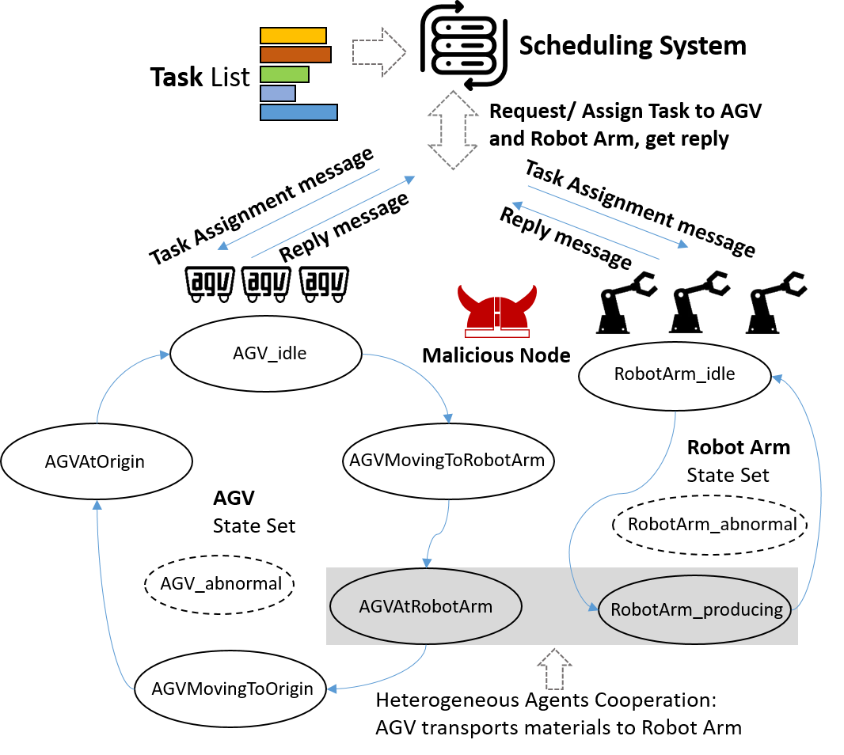
Fig. 1 Schematic Diagram of an Industrial Multi-Agent System with AGVs and Robot Arms
With the deepening integration of the internet and industrial networks, the risk of attacks on industrial networks has gradually increased, and the possibility of malicious nodes appearing in the network has also risen [13]. Malicious nodes may launch attacks on the system network, such as refusing to respond, sending false information, or replaying old messages, to disrupt the information consensus [18]. Therefore, introducing Byzantine consensus mechanisms into industrial networks to effectively identify and distinguish between agent single point failure and malicious node masquerading has become increasingly important and necessary.
After introducing the Byzantine consensus mechanism, each component plays the following roles during the consensus process:
Scheduling System: The scheduling system acts as the coordinator of the consensus process. It is responsible for initiating the consensus process, distributing tasks, and formally announcing task execution once consensus is reached. It initiates the consensus by sending a pre-prepare message and completes the consensus after receiving sufficient confirmations.
AGV: In addition to handling material transportation tasks, AGVs also act as participants in the consensus process. They are responsible for confirming whether the tasks assigned by the scheduling system align with their current states. AGVs receive pre-prepare messages, validate the tasks, and send prepare messages, thereby contributing to the consensus formation.
Robot Arm: In addition to processing and manufacturing materials, the Robot Arm serves as another important participant in the consensus process in task pairing with AGVs. Similar to the AGV's participation in consensus, it sends pre-prepare, prepare, and commit messages during the consensus process to ensure the correct execution of tasks.
Malicious Nodes: Malicious nodes attempt to disrupt the system's consensus process by refusing to respond, sending false information, or replaying old messages.
Although the Byzantine consensus mechanism is highly effective in ensuring fault tolerance, it has a message complexity of 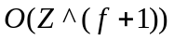 in scenarios where the total number of nodes is  and the number of malicious nodes is . This often results in excessive communication and computational overhead, making it difficult to apply in practical scenarios [14]. To address these practical limitations, Practical Byzantine Fault Tolerance (PBFT) was developed as an optimized variant to reduce complexity and improve efficiency. A schematic diagram of the PBFT consensus mechanism for an industrial multi-agent system involving AGVs and Robot Arms is shown in Fig. 2.
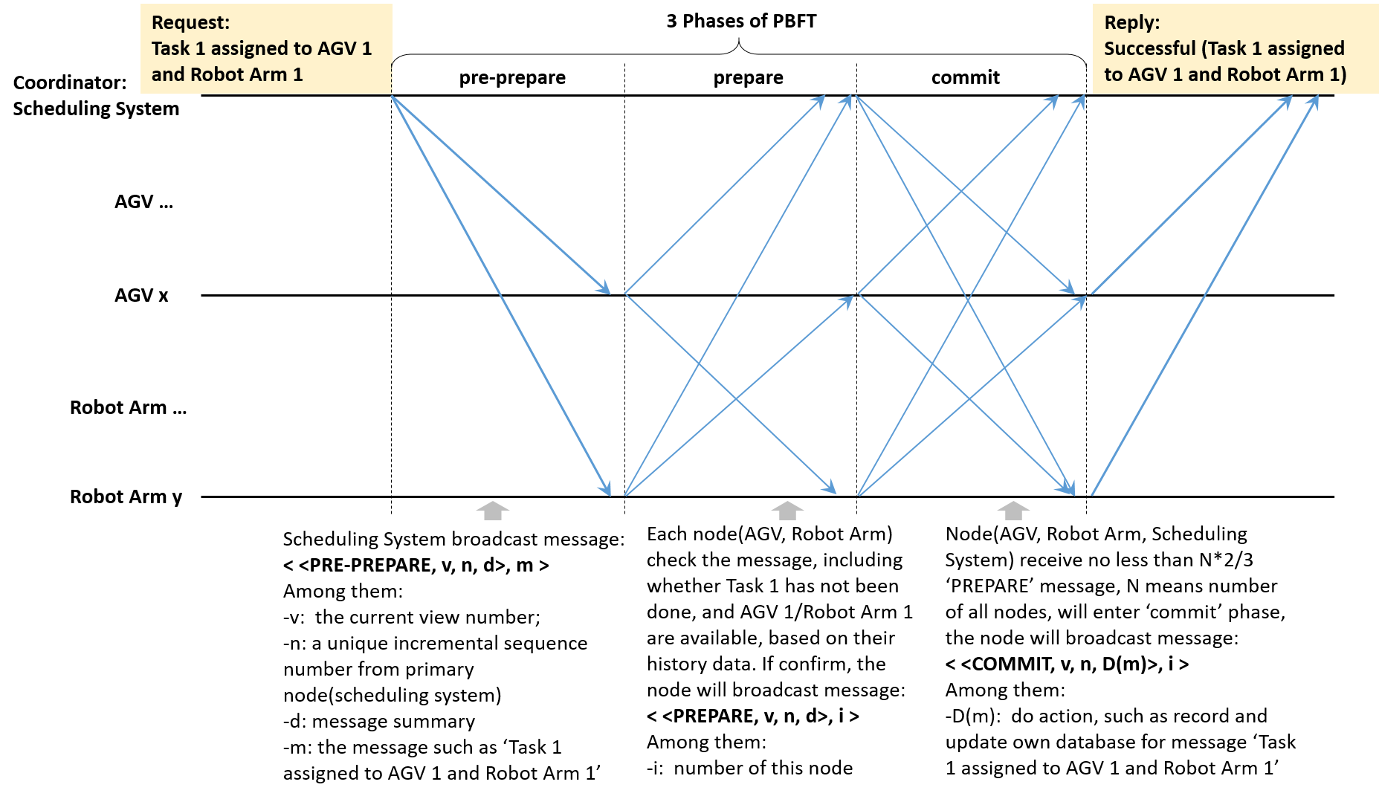
Fig.2 Practical Byzantine Consensus in an Industrial Multi-Agent System with AGVs and Robot Arms
From the perspective of the service requester, the Byzantine consensus protocol consists of three steps: request, processing requests, and reply. Practical Byzantine Fault Tolerance further divides the processing requests step into three phases: pre-prepare, prepare, and commit [15].
1. In our example of an industrial multi-agent system, the scheduling system not only serves as the service requester (client), but also acts as the coordinator (or primary node) and initiates the consensus process by broadcasting a pre-prepare message to all nodes. The broadcasted message is:
< <PRE-PREPARE, v, n, d>, m >
Among them:
-v: the current view number;
-n: a unique incremental sequence number from primary node(scheduling system)
-d: message summary
-m: the message such as ‘Task 1 assigned to AGV 1 and Robot Arm 1’
2. In Prepare phase, Each node (AGV, Robot Arm) check the message from scheduling system, including whether Task 1 has not been done yet, and whether both AGV 1 and Robot Arm 1 are available, based on their history data. If confirm, the node will broadcast message:
< <PREPARE, v, n, d>, i >
Among them:
-i: number of this node
3. If the node(AGV, Robot Arm, Scheduling System) receive no less than 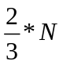 ‘PREPARE’ message, with  means number of all nodes, will enter ‘commit’ phase, the node will broadcast message:
< <COMMIT, v, n, D(m)>, i >
Among them:
-D(m): do action, such as record and update own database for message ‘Task 1 assigned to AGV 1 and Robot Arm 1’
If an agent (AGV or Robot Arm) needs to send its own status information, it must do so through the scheduling system, which acts as the coordinator of the consensus process. For instance, if AGV 1 needs to exit the queue due to a low battery, the process using Practical Byzantine Fault Tolerance can be illustrated as shown in Fig. 3.
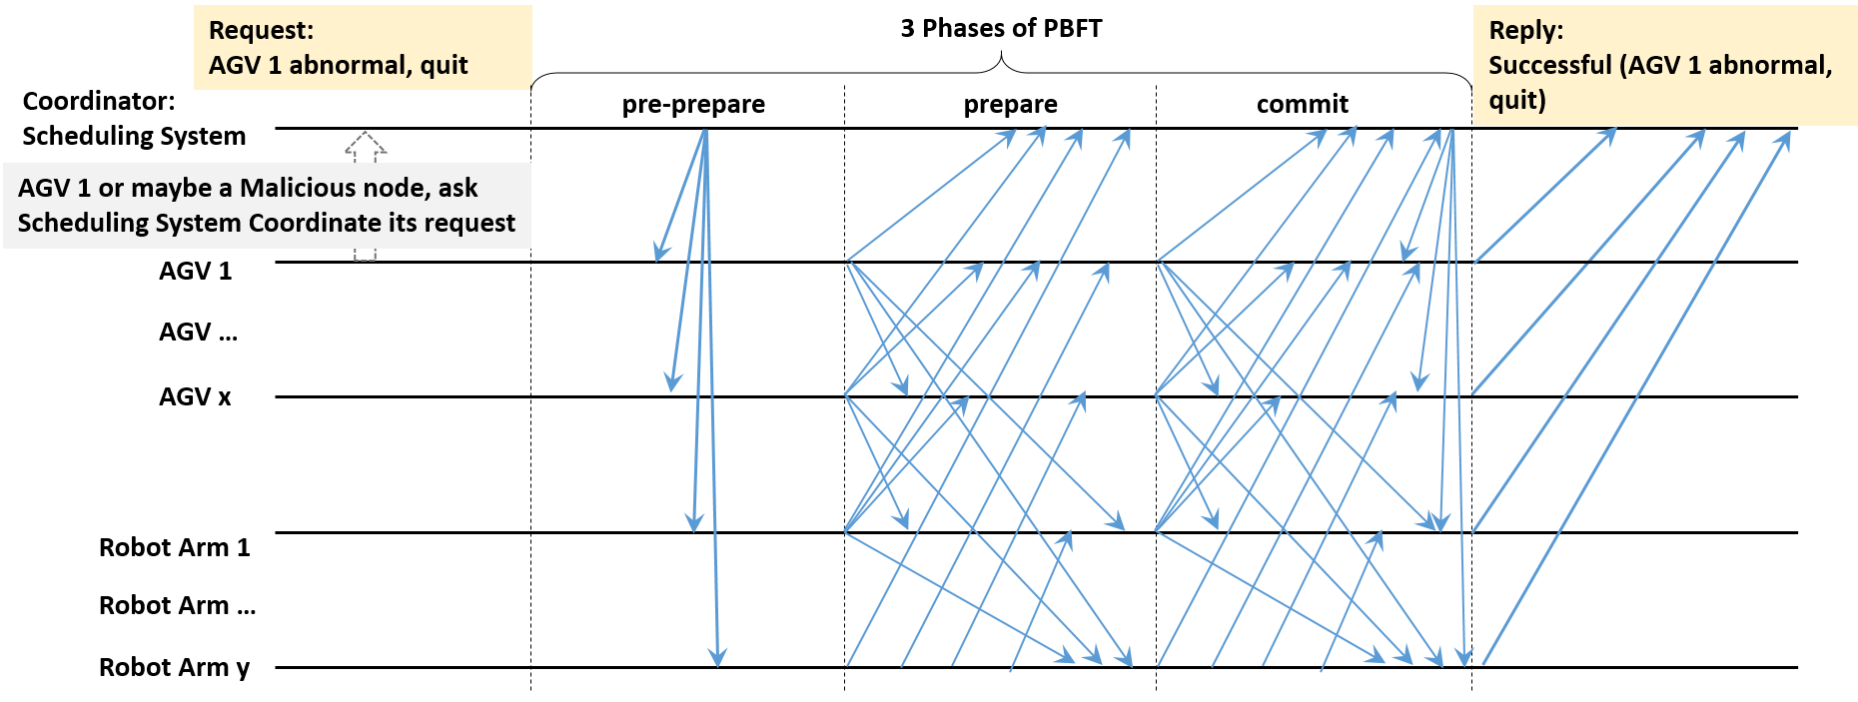
Fig. 3 PBFT Process for AGV State Update in Industrial Multi-Agent System
Practical Byzantine Fault Tolerance (PBFT) has made some improvements in reducing the complexity of traditional Byzantine consensus, but it still has limitations in practical applications. Since every node needs to exchange messages with all other nodes, it results in significant communication overhead. If there are  AGVs and Robot Arms, each node must interact with every other node during each consensus phase, leading to a message complexity of 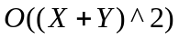 [16]. This will result in a very high communication load when the number of system nodes is large. Considering that during the normal completion of a task, an AGV undergoes five state transitions and a Robot Arm undergoes two state transitions, this will severely impact the overall efficiency of the system.

Spatiotemporal Feature-Enhanced and Task-Coupled Lightweight Byzantine Consensus Mechanism

Security Enhancement with Spatiotemporal Features
In the context of Byzantine consensus, ensuring the integrity and authenticity of messages exchanged between agents is crucial. Traditional Byzantine Fault Tolerance (BFT) and existing improved mechanisms often rely solely on the consensus of messages, but they fail to sufficiently account for the authenticity of the message's source and its contextual validity. To address this gap, we propose an enhancement to the consensus mechanism by integrating spatiotemporal features, namely timestamps and spatial location data, into the messages exchanged during the consensus process. This enhancement introduces an additional layer of security, making it more difficult for malicious nodes to inject fraudulent or replayed messages into the system.
Timestamps and Spatial Information in Consensus Messages:
Each message sent by an agent (e.g., AGV, Robot Arm) in the system contains both timestamp and spatial location data. The timestamp indicates the exact time at which the message was generated, and the spatial location indicates the physical position of the agent at that time. Formally, let 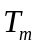​ represent the timestamp of a message , and let 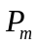​ represent the spatial location of the agent that sent mmm. The message structure can be described as:
(1)
Where ​ is a precise time tag (e.g., in the format HH:MM:SS), and 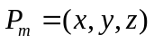 represents the coordinates of the agent at the moment the message is sent.
The introduction of these spatiotemporal features ensures that each message is uniquely identifiable and anchored to a specific time and location, making it resistant to replay attacks and providing a strong basis for context verification.
Malicious Node Detection:
The core objective of integrating spatiotemporal features is to detect and reject messages from potentially malicious nodes. Specifically, if a message contains invalid or inconsistent data, such as an incorrect timestamp, anomalous spatial location, or mismatched task information, the system will consider this as an anomaly and reject the message. This is achieved through a series of validation checks to detect the spatiotemporal consistency of messages, ensuring only legitimate messages that meet the expected criteria can participate in the consensus process.
Let us define a valid message 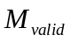 as one where the following conditions hold true:
1. Timestamp validity: The timestamp ​ must fall within an acceptable time window relative to the current system time. Formally:
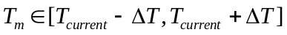 (2)
where 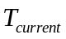​ is the system’s current time, and 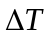 is an allowable time deviation that accounts for potential communication delays or clock discrepancies.
2. Spatial location validity: The reported spatial location must be within a reasonable physical region relative to the agent's expected trajectory. Let 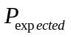 be the predicted location of the agent based on its last known position and movement. The message is valid if:
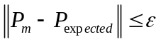 (3)
where is a threshold distance that determines the maximum allowable deviation from the expected location.
3. Task consistency: The message must correspond to a valid task in the system’s task assignment table. If the task information 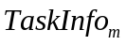 does not match the agent’s assigned task, the message is considered invalid. This can be represented as:
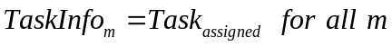 (4)
If any of the above conditions are violated, the message is immediately rejected. This ensures that only valid, timely, and spatially consistent messages contribute to the consensus process, thus preventing malicious nodes from manipulating the system.
By integrating spatiotemporal validation, we significantly enhance the security of the consensus mechanism. Malicious nodes attempting to replay outdated messages or inject erroneous data with inconsistent timestamps or locations will be detected and excluded from the consensus process. This protection mechanism also limits the ability of adversaries to exploit the inherent vulnerabilities of network communication, such as packet delay or reordering, which could otherwise be used to disrupt the consensus process.
Moreover, the use of spatiotemporal features also has the advantage of reducing the computational overhead compared to more traditional cryptographic methods. Since the verification relies on simple timestamp checks and spatial consistency, it is computationally lightweight while still providing a robust layer of security. This makes the proposed approach particularly suitable for resource-constrained environments such as industrial multi-agent systems.

Task-Coupled Lightweight Consensus Mechanism
In a multi-agent system, tasks typically involve the cooperation of multiple agents. For example, AGVs need to work together with Robot Arms to perform material transport and processing tasks. PBFT mechanisms require all nodes in the system to participate in the consensus process for every task, but in reality, wen can limit that only the nodes directly related to the current task need to be involved in the consensus.
The task-coupled consensus mechanism builds on this idea by classifying nodes into task-related and unrelated nodes. Only the nodes related to the current task, such as the AGV and Robot Arm executing the task, as well as the scheduling system, will participate in the consensus process. The system determines which nodes should participate in the consensus and which can be excluded based on the task status and dependencies. Each node, upon receiving the task assignment, first determines whether it is part of the task. If so, it enters the consensus process; otherwise, it does not participate. This method avoids the involvement of unrelated nodes, significantly reducing the communication complexity of the system.
Define the set of all nodes in the system as , which includes all scheduling systems, AGVs, and Robot Arms:
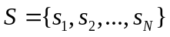 (5)
where represents the total number of nodes in the system.
For a given task 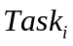​, the set of nodes involved in the task is represented as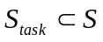, indicating the nodes that are directly involved in task ​ (e.g., the AGV handling material transport and the Robot Arm performing processing):
(6)
The set of unrelated nodes 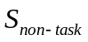​ consists of all nodes in the system that are not involved in the current task :
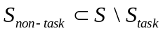 (7)
When the scheduling system assigns task , each node 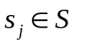 receives the task allocation information and determines if it is part of the task-related set 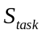​:
(8)
Only if a node 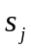​ belongs to the set ​, it will participate in the consensus process. Otherwise, it will not participate in the consensus for the given task. This decision can be expressed as follows:
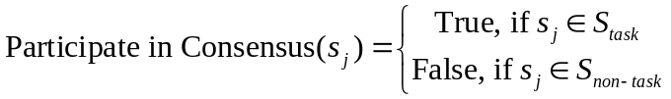 (9)
Taking the example of AGV 1 needing to quit the scheduling queue during the execution of Task 1 due to abnormal (e.g. low battery), the entire process is illustrated in Fig. 4.
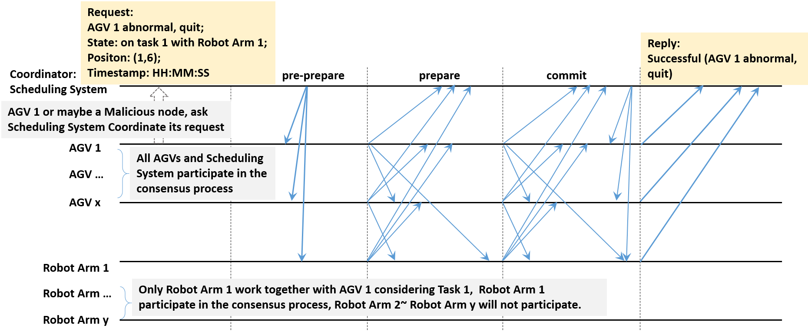
Fig. 4 Consensus Process for AGV Quit Request During Task Execution
AGV 1 needs to send a request to the scheduling system to initiate the consensus process. The scheduling system first checks the timestamp and spatial location information to preliminarily determine whether the information is from a malicious node. After the information passes this check, the consensus process proceeds. Since Task 1 is completed by AGV 1 and Robot Arm 1, the consensus process only requires the scheduling system, all AGVs, and Robot Arm 1 to participate; other Robot Arms do not need to participate in the consensus process.
After the task is completed, the nodes involved in the consensus will update their status, and the task information will be propagated to other nodes not involved in the consensus in the system to prepare for subsequent tasks.

Adaptive Weight Mechanism for Consensus Robustness
In the proposed consensus mechanism, an adaptive weight mechanism is introduced to dynamically adjust the influence of nodes in the consensus process based on their historical behavior. Initially, all nodes are assigned equal weights 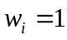, where represents the node ​. As the consensus process progresses, the weight of each node is adjusted dynamically depending on its behavior. Nodes that demonstrate suspicious or malicious activities have their weights reduced.
Let the set of nodes in the system be . For each node 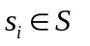, a weight 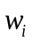 is assigned to represent its influence in the consensus process. Initially:
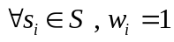 (10)
The weight of a node is dynamically adjusted based on its observed behavior. Specifically, if a node is detected to engage in suspicious activities—such as sending conflicting messages, attempting replay attacks, or deviating from expected behavior—its weight is reduced according to a penalty function. Let 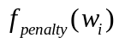 be the penalty function that reduces the weight of node ​:
(11)
Here, 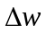 represents the decrement applied to the weight of a node for each detected malicious action. The penalty function ensures that weights are non-negative and decrease progressively for repeated offenses. Consequently, nodes with repeated suspicious behavior will see their influence in the consensus process gradually diminish, thereby minimizing their impact on the consensus outcome.
In PBFT consensus, consensus is reached when more than two-thirds of the nodes agree [17]. In the proposed adaptive mechanism, we extend this condition by considering the weights of the nodes. Specifically, consensus is reached when the sum of the weights of agreeing nodes exceeds two-thirds of the total weight in the system. Let 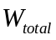​ represent the total weight of all nodes in the system:
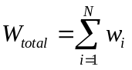 (12)
Consensus is achieved if the sum of the weights of agreeing nodes 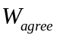​ satisfies:
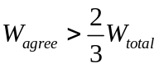 (13)
This weighted consensus approach makes the mechanism more robust against malicious nodes. Nodes that are detected as behaving maliciously will have their weights reduced, thereby reducing their ability to interfere with the consensus process. This mechanism also incentivizes honest behavior, as nodes that consistently act in a trustworthy manner retain their initial weight, ensuring their influence in the consensus process remains strong.
The new mechanism proposed in this paper can reduce the information complexity of the consensus process in most scenarios. We can represent the information complexity for different cases using mathematical notation, as follows:
1. If the message cannot pass spatiotemporal feature checks:
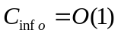 (14)
In this case, the scheduling system directly rejects the message, and there is no need to initiate the consensus process, resulting in a constant information complexity. When malicious nodes attempt an attack, most fail to "perfectly" forge information and thus fall under this category.
2. If the message is initiated by an AGV or Robot Arm:
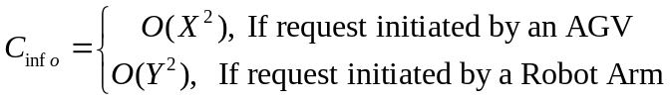 (15)
Where represents the number of AGV nodes, and represents the number of Robot Arm nodes. This scenario accounts for the majority of normal communication.
3. If the message is initiated by the scheduling system:
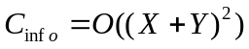 (16)
Where represents the number of AGV nodes, and represents the number of Robot Arm nodes. In this case, the scheduling system, as the coordinator, needs to communicate with all relevant AGV and Robot Arm nodes.

EXPERIMENTAL EVALUATION
We conducted our experiments using CORE Emulator (version 9.1.0), a tool for building virtual networks, available at https://github.com/coreemu/core. The computer configuration included an Intel Xeon W-1270 CPU (3.40GHz), 64GB of RAM, and an NVIDIA RTX A3000 (6GB) GPU. Our new mechanism was implemented using Python (version 3.9.0) scripts and integrated into the CORE Emulator environment to facilitate performance comparison with other algorithms.
In this experimental evaluation, we compared the performance of four consensus mechanisms: Traditional Byzantine, PBFT (Practical Byzantine Fault Tolerance), SBFC (Simplified Byzantine Fault Consensus), and our proposed New Mechanism (STCL-BFT, Spatiotemporal Feature-Enhanced and Task-Coupled Lightweight Byzantine Consensus Mechanism). These mechanisms represent the classical Byzantine protocol, the practical Byzantine fault-tolerant protocol, a simplified version with reduced communication complexity, and our proposed lightweight mechanism tailored for industrial multi-agent systems.
In the experiments, approximately one-third of the malicious nodes had their messages directly rejected by the scheduling system due to discrepancies in spatiotemporal features, without requiring the consensus process. The remaining two-thirds of malicious nodes managed to send "perfectly disguised" messages, necessitating the use of the STCL-BFT consensus algorithm. This scenario represents a very strict condition; in most real-world cases, the majority of malicious nodes fail to achieve perfect disguise, allowing the spatiotemporal feature mechanism of STCL-BFT to immediately identify and reject their interference without entering the consensus process.
The experiments focused on evaluating the performance of each mechanism in terms of consensus base delay and communication cost.

Comparison of Consensus Base Delay
The consensus base delay is a critical metric for evaluating the efficiency of various Byzantine consensus mechanisms in a multi-agent system. Figure 5 presents a comparison of the consensus base delay among four different mechanisms.
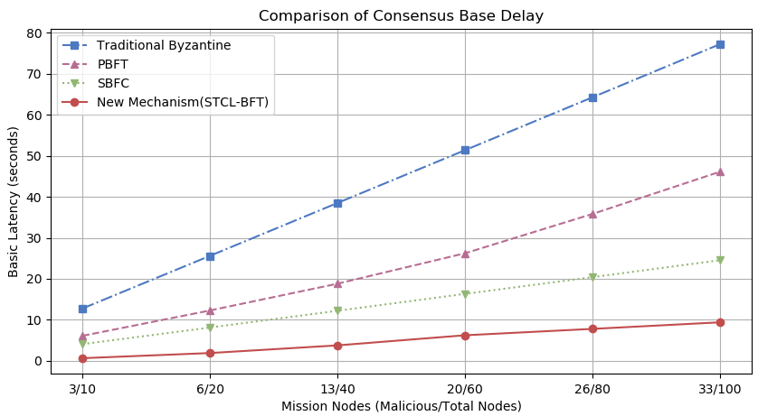
Fig. 5 comparison of the consensus base delay among four different mechanisms
In this experiment, we assessed the latency required for consensus formation as the total number of mission nodes increased, including both malicious nodes (disguise as AGVs in abnormal status) and total nodes (including Scheduling System, AGVs and Robot Arms). The x-axis of the plot represents the number of mission nodes as "Malicious/Total Nodes," while the y-axis shows the basic latency measured in seconds.
The Traditional Byzantine mechanism demonstrated the highest consensus delay, which increased significantly with the number of mission nodes. This is primarily due to the communication complexity inherent in involving all nodes in the consensus process. The delay quickly escalates as the number of nodes grows, which makes the mechanism unsuitable for large-scale or real-time systems.
PBFT showed improved latency compared to the Traditional Byzantine mechanism. However, it still exhibited a relatively high consensus delay when the number of nodes reached a larger scale. This is due to the quadratic communication cost among nodes during the consensus phases.
The SBFC mechanism, which aims to simplify the consensus process by reducing the communication overhead, demonstrated a moderate reduction in latency. Despite its simplifications, the consensus delay still increases substantially with the growth in node count.
In contrast, our proposed New Mechanism (STCL-BFT) achieved the lowest consensus base delay across all configurations. This significant reduction is attributed to three key factors:
1. Security Enhancement with Spatiotemporal Features, can do early detection of some obviously malicious nodes without initiating a full consensus process, thus reducing unnecessary communication.
2. Task-Coupled Lightweight Consensus Mechanism, by involving only task-related nodes in the consensus process, the mechanism effectively minimized communication complexity, thereby reducing latency.
3. Adaptive Weight Mechanism for Consensus Robustness, this dynamic adjustment of node weights helped to prioritize reliable nodes, further expediting the consensus process.
Overall, our proposed mechanism demonstrate efficiency in reducing the consensus base delay. Compared to the PBFT mechanism, our proposed STCL-BFT significantly reduced the overall communication cost by approximately 85%. This result indicates that STCL-BFT is well-suited for application in large-scale industrial multi-agent environments, where real-time consensus is crucial.

Comparison of Communication Cost
The communication cost is a crucial metric in evaluating the efficiency of consensus mechanisms, especially in multi-agent systems where network bandwidth and resource efficiency are critical. Figure 6 presents a comparison of the total communication cost during the consensus formation process among four different consensus mechanisms.
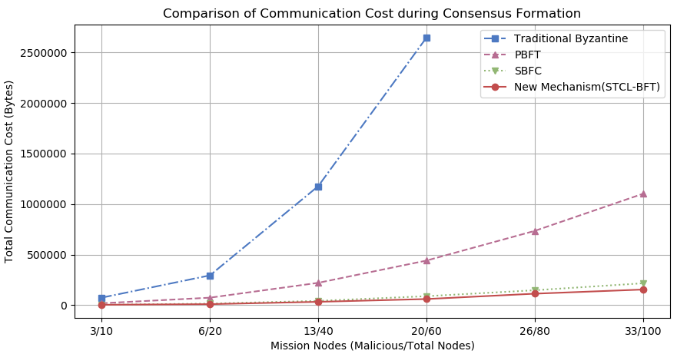
Fig. 6 comparison of the Communication Cost among four different mechanisms
The x-axis represents the number of mission nodes as "Malicious/Total Nodes," while the y-axis shows the total communication cost in bytes. The analysis focuses on the amount of data exchanged during the consensus process under increasing numbers of nodes, including both malicious and total nodes.
The Traditional Byzantine mechanism exhibited the highest communication cost. As the number of mission nodes increased, the communication cost grew significantly, eventually becoming prohibitively high at larger node counts. This is primarily due to the communication complexity associated with involving all nodes in multiple rounds of message exchanges, which led to an exponential increase in data transfer.
The PBFT mechanism performed better than the Traditional Byzantine mechanism in terms of communication cost. However, it still demonstrated a trend of squared growth. This is due to the quadratic message complexity during the consensus phases, which involves many redundant communications among nodes to ensure fault tolerance.
The SBFC mechanism showed a moderate reduction in communication cost compared to PBFT, thanks to its simplification of the consensus protocol and reduced message exchanges. Nevertheless, it still requires a considerable amount of data to be exchanged, especially when the network size scales up.
In contrast, our proposed New Mechanism (STCL-BFT) demonstrated a significantly lower communication cost across all mission node configurations. The 3 key features contributed to this improvement:
1. Security Enhancement with Spatiotemporal Features, make it possible to identify malicious nodes without initiating a full consensus process, thus effectively reducing unnecessary communication.
2. Task-Coupled Lightweight Consensus Mechanism, ensure only task-relevant nodes participated in the consensus, thereby eliminating redundant communication among irrelevant nodes and significantly reduce the overall data exchange.
3. Adaptive Weight Mechanism for Consensus Robustness, ensured that trustworthy nodes had a higher influence, which minimized the need for repeated communication.
Our proposed STCL-BFT improved the consensus formation speed by more than 60% compared to the PBFT mechanism. This indicates that our proposed New Mechanism is highly efficient in minimizing bandwidth usage and scaling effectively, making it suitable for real-time industrial multi-agent systems where reducing communication overhead is critical.

CONCLUSIONS AND FUTURE WORK
In this paper, we proposed a Spatiotemporal Feature-Enhanced and Task-Coupled Lightweight Byzantine Consensus Mechanism for industrial multi-agent systems. Through a comparative analysis, we have highlighted the significant improvements of our proposed mechanism over the PBFT approach in terms of efficiency, security, and robustness. As shown in Table 1.
Table 1 Comparison Between PBFT and the Proposed Lightweight Byzantine Consensus Mechanism
Comparison Aspect | PBFT | New Mechanism (Lightweight Byzantine Consensus Mechanism)
Node Participation | All nodes need to participate in every consensus process | Only task-related nodes participate, leading to higher efficiency
Communication Complexity | 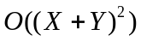 | Special cases/best performance: 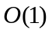  High probability: 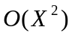 or 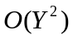  Low probability:
Security Enhancement | No temporal and spatial verification | Incorporates timestamp and spatial information to defend against replay attacks and malicious behavior
Handling Malicious Nodes | Relies on node count threshold | Adaptive weight mechanism dynamically reduces the influence of malicious nodes
Consensus Condition | Agreement from more than two-thirds of nodes | Agreement from more than two-thirds of total weight, considering node reliability
Computational Complexity | High computational cost | Task coupling and adaptive weight adjustments reduce computational complexity
Applicability | Suitable for high-trust or low-dynamic environments | More suitable for dynamic industrial multi-agent environments
Consensus Efficiency | High consensus delay | Significant efficiency improvement by reducing node participation and communication
For future work, we aim to explore further optimization of the adaptive weight mechanism, considering more complex behavior patterns of nodes. Additionally, we plan to extend the applicability of our mechanism to other industrial scenarios that involve a higher degree of node mobility and varying communication constraints, further testing the scalability and adaptability of the proposed solution.

References:

- Kong L, Chen B, Hu F. LAP-BFT: lightweight asynchronous provable byzantine fault-tolerant consensus mechanism for UAV network[J]. Drones, 2022, 6(8): 187.
- Goyal H, Saha S. Reli: Real-time lightweight byzantine consensus in low-power iot-systems[C]//2022 18th International Conference on Network and Service Management (CNSM). IEEE, 2022: 275-281.
- Jin Y, Liang J, Li X, et al. Simplified Byzantine Fault Tolerant Consensus Algorithm for Distributed Energy Trading[J]. Available at SSRN 4490267.
- Kapitza R, Behl J, Cachin C, et al. CheapBFT: Resource-efficient Byzantine fault tolerance[C]//Proceedings of the 7th ACM european conference on Computer Systems. 2012: 295-308.
- Wu C, Qin H, Javad Amiri M, et al. Towards Truly Adaptive Byzantine Fault-Tolerant Consensus[J]. ACM SIGOPS Operating Systems Review, 2024, 58(1): 15-22.
- Zhao Y, Qu Y, Xiang Y, et al. A lightweight model-based evolutionary consensus protocol in blockchain as a service for IoT[J]. IEEE Transactions on Services Computing, 2023, 16(4): 2343-2358.
- Li C, Qiu W, Li X, et al. A Dynamic Adaptive Framework for Practical Byzantine Fault Tolerance Consensus Protocol in the Internet of Things[J]. IEEE Transactions on Computers, 2024.
- Zhong W, Yang C, Liang W, et al. Byzantine fault-tolerant consensus algorithms: A survey[J]. Electronics, 2023, 12(18): 3801.
- Zhang L, Zhang B, Li C. An efficient and reliable byzantine fault tolerant blockchain consensus protocol for single-hop wireless networks[J]. IEEE Transactions on Wireless Communications, 2023.
- Imran M, Yao B, Ali W, et al. Research perspectives and challenges of blockchain for data-intensive and resource-constrained devices[J]. IEEE Access, 2022, 10: 38104-38122.
- Karimireddy S P, He L, Jaggi M. Learning from history for byzantine robust optimization[C]//International Conference on Machine Learning. PMLR, 2021: 5311-5319.
- Kattepur A, Rath H K, Simha A, et al. Distributed optimization in multi-agent robotics for industry 4.0 warehouses[C]//Proceedings of the 33rd Annual ACM Symposium on Applied Computing. 2018: 808-815.
- Cheminod M, Durante L, Valenzano A. Review of security issues in industrial networks[J]. IEEE transactions on industrial informatics, 2012, 9(1): 277-293.
- Galil Z, Mayer A, Yung M. Resolving message complexity of byzantine agreement and beyond[C]//Proceedings of IEEE 36th Annual Foundations of Computer Science. IEEE, 1995: 724-733.
- Castro M, Liskov B. Practical byzantine fault tolerance and proactive recovery[J]. ACM Transactions on Computer Systems (TOCS), 2002, 20(4): 398-461.
- Na Y, Wen Z, Fang J, et al. A derivative PBFT blockchain consensus algorithm with dual primary nodes based on separation of powers-DPNPBFT[J]. IEEE Access, 2022, 10: 76114-76124.
- Mišić J, Mišić V B, Chang X, et al. Adapting PBFT for use with blockchain-enabled IoT systems[J]. IEEE Transactions on Vehicular Technology, 2020, 70(1): 33-48.
- Bouali T, Senouci S M, Sedjelmaci H. A distributed detection and prevention scheme from malicious nodes in vehicular networks[J]. International Journal of Communication Systems, 2016, 29(10): 1683-1704.
- Upadhyay V, Vaish D A, Kokila D J. The need for Lightweight Consensus algorithms in IoT environment: A review[C]//Proceedings of the 2024 Sixteenth International Conference on Contemporary Computing. 2024: 366-376.
- Mao Y. State machine replication for wide area networks[D]. UC San Diego, 2010.

